Notes regarding setting up your Ajera DSN (Data Source Name).

There are two options for the logon script for SQL server:

- Integrated Windows Authentication or NT authority
- A separate login ID and password.

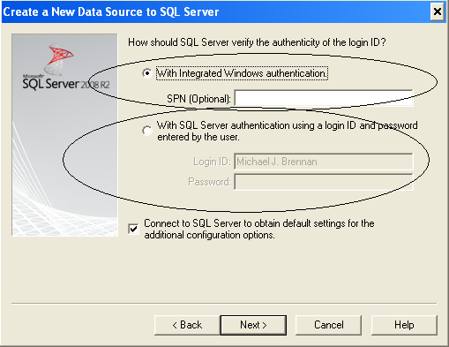

- If Ajera is the only program using the SQL server database on the physical or virtual server, the default installation would have used Windows Authentication.
- Try setting it up using Window Authentication. If the tests fail, then your SQL Server was installed using a separate Login ID and password.
- Multiple instances of SQL server can exist on the same physical or virtual server. The first instance or default instance would have been when the first program using SQL Server was installed. It was installed with a separate user ID and password.

The image below was captured from my personal computer. The setup utility found six instances of SQL server.

- Other SQL Servers on Network (Ignore)
  - Office (Default Instance)
  - Office\Axium (Ajera Instance)
- Ajera SQL Server
  - UNLOCKTHEDATA5 (Default)
  - UNLOCKTHEDATA5\AXIUM (Ajera)
  - UNLOCKTHEDATA5\MSSMLBIZ (Unrelated)
  - UNLOCKTHEDATA5\RATIOINSTANCE (Unrelated)

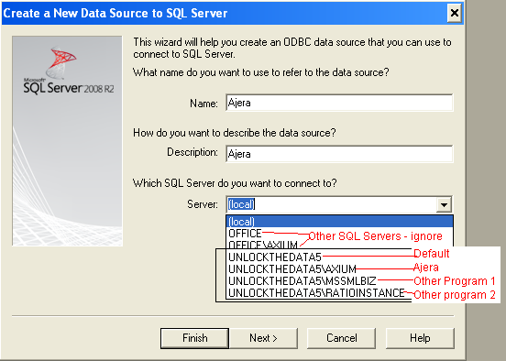

Based on the above, I can conclude the following:
  - Other programs using SQL server are installed on the physical server “UNLOCKTHEDATA5”.
  - If windows authentication does not work, then Ajera was installed after the default instance was created.
  - The default instance uses a separate user name and password.
  - I need a separate user name and password to gain access to the Ajera database from the backend.
  - The default used name for SQL server is “sa” (System Administrator).
  - The Ajera master password is most likely NOT your “sa” password.

If windows authentication is not in place, you have two options for back end access to the Ajera database.
- logon using the “sa” user name and password.
- Have your windows/network user name (ID) add to the administrators group for the Ajera server.

